Section I: Scenario Demographics

Scenario Title: | Unstable Bradycardia
Date of Development: | 18/07/2015
Target Learning Group: | Juniors (PGY 1 – 2) Seniors (PGY ≥ 3) All Groups

Section II: Scenario Developers

Scenario Developer(s): | Martin Kuuskne
Affiliations/Institution(s): | McGill University
Contact E-mail (optional): | martin.kuuskne@mail.mcgill.ca

Section III: Curriculum Integration

Learning Goals & Objectives
Educational Goal: | To manage a patient with unstable bradycardia leading to cardiac arrest
CRM Objectives: | - Predicts the likelihood of deterioration in a patient with bradycardia and describes a plan of management to team members.  - Recognizes the need to effectively utilize resources by optimizing pharmacologic therapy and instituting transcutaneous pacing in addition to early consultation with cardiology for placement of an intravenous pacemaker.
Medical Objectives: | - Employ a intravenous chronotropic agent for unstable bradycardia  - Promptly recognize pulseless electrical activity in the setting of an unstable patient.

Case Summary: Brief Summary of Case Progression and Major Events
A 78-year-old male presents to the emergency department with an unstable bradycardia. The patient deteriorates from a second degree, Mobitz Type II-AV block into a third degree AV block requiring ACLS protocol medications, transcutaneous pacing, and ultimately transvenous pacing until definitive management with a permanent pacemaker can be arranged.

References
Marx, J. A., Hockberger, R. S., Walls, R. M., & Adams, J. (2013). Rosen's emergency medicine: Concepts and clinical practice. St. Louis: Mosby

Section IV: Scenario Script

A. Clinical Vignette: To Read Aloud at Beginning of Case
A 78-year-old male from a long-term care facility is being transferred to the emergency department for decreased mental status.
B. Scenario Cast & Realism
Patient: | Computerized Mannequin |  |  |  |  | Realism:  Select most important dimension(s) |  |  | Conceptual
 | Mannequin |  |  |  |  |  |  |  | Physical
 | Standardized Patient |  |  |  |  |  |  |  | Emotional/Experiential
 | Hybrid |  |  |  |  |  |  |  | Other:
 | Task Trainer |  |  |  |  |  |  |  | N/A
Confederates | Brief Description of Role
N/A | N/A
C. Required Monitors
EKG Leads/Wires |  |  | Temperature Probe |  |  |  | Central Venous Line
NIBP Cuff |  |  | Defibrillator Pads |  |  |  | Capnography
Pulse Oximeter |  |  | Arterial Line |  |  |  | Other:
D. Required Equipment
Gloves |  |  | Nasal Prongs |  |  |  | Scalpel
Stethoscope |  |  | Venturi Mask |  |  |  | Tube Thoracostomy Kit
Defibrillator |  |  | Non-Rebreather Mask |  |  |  | Cricothyroidotomy Kit
IV Bags/Lines |  |  | Bag Valve Mask |  |  |  | Thoracotomy Kit
IV Push Medications |  |  | Laryngoscope |  |  |  | Central Line Kit
PO Tabs |  |  | Video Assisted Laryngoscope |  |  |  | Arterial Line Kit
Blood Products |  |  | ET Tubes |  |  |  | Other:
Intraosseous Set-up |  |  | LMA |  |  |  | Other:
E. Moulage
Clothing/attire to fit patient age, elderly mask on the mannequin if available.

F. Approximate Timing
Set-Up: |  | 5 min |  | Scenario: | 10 min |  |  | Debriefing: |  | 10 min

Section V: Patient Data and Baseline State

A. Patient Profile and History
Patient Name: Gabriel DeFabio |  |  |  |  |  | Age: 78 |  |  |  |  |  |  |  | Weight: 100kg
Gender: M F |  |  |  |  |  | Code Status: Full-Code
Chief Complaint: Altered Mental Status
History of Presenting Illness: The patient was found at his residence with an altered mental status. The caretakers noticed “abnormal movements” twitching of his head and the patient was not responding appropriately. There was no history of chest-pain or shortness of breath prior to the episode.
Past Medical History: |  | CAD with remote MI |  |  |  |  | Medications: |  |  |  |  | ASA 80mg PO Daily
 |  | HTN |  |  |  |  |  |  |  |  |  | Bisoprolol 5mg PO Daily
 |  | Hypothyroidism |  |  |  |  |  |  |  |  |  | Levothyroxine 0.88mg PO Daily
 |  | Gout |  |  |  |  |  |  |  |  |  | Colchicine 0.6mg PO daily
Allergies: Penicillin
Social History: non contributory
Family History: non contributory
Review of Systems: |  | CNS: |  |  | Patient has a decreased mental status
 |  | CVS: |  |  | No chest pain
 |  | RESP: |  |  | No SOB
 |  | GI: |  |  | No GI changes
 |  | GU: |  |  | No GU changes
 |  | MSK: |  |  | No Complaints |  |  |  |  |  |  |  | INT: |  | Normal
B. Baseline Simulator State and Physical Exam
No Monitor Display |  |  |  | Monitor On, no data displayed |  |  |  |  |  |  | Monitor on Standard Display
HR: 40/min |  |  | BP: 97/63 |  |  |  |  | RR: 12/min |  |  |  |  |  |  | O₂SAT: 91%
Rhythm: 2ºAVB Mobitz II |  |  | T: 35.9ºC |  |  |  |  | Glucose: 7.0 mmol/L |  |  |  |  |  |  | GCS: 9 (E2V3M4)
General Status: Decreased mental status
CNS: | Pearl, withdrawing all limbs to pain.
HEENT: | Normal
CVS: | Bradycardia
RESP: | GAEB
ABDO: | Soft, non-tender
GU: | Normal
MSK: | Normal |  |  |  |  |  |  |  | SKIN: | Normal, cap refill >3 seconds.

Scenario States, Modifiers and Triggers
Patient State | Patient Status | Learner Actions, Modifiers & Triggers to Move to Next State
1. Baseline State  Rhythm: 2⁰AVB Mobitz II  HR: 40/min  BP: 97/63  RR: 12/min  O₂SAT: 91%  T: 36.1ºC | Decreased mental status,  GCS: 9 | Learner Actions  -Attaches monitors  -Acquires IV access  -Supplemental O₂  -Hx/Physical Exam  -EKG/CXR  -Lab investigations  -Recognizes unstable brady  -Atropine IV 0.5mg  - IV NS Bolus | Modifiers  Changes to patient condition based on learner action  - Supplemental O₂ O₂SAT to 95%  Triggers  For progression to next state  - 3 minutes 2. 3⁰ AVB
2. 3⁰- AVB  Rhythm: 3⁰AVB  HR: 26  BP: 61/42 | Decreased mental status,  GCS: 9 | Learner Actions  -Atropine IV 0.5mg  -Dopamine/Epinephrine infusion  - Isoproterenol Infusion  - EKG  -Transcutaneous Pacing  -IV Analgesic for pacing | Modifiers  - IV chronotropic agent HR to 40, BP:70/45  - Transcutaneous pacing No mechanical capture until 70mA  Triggers  - 3 minutes without pacing 3. PEA  - If begins pacing 4. Paced Rhythm
3. PEA  BP: 0/0  RR: 0  O₂SAT: 0% | Non-responsive | Learner Actions  -Chest compressions  -1mg Epinephrine IV  -Crash intubation | Modifiers  Intubation Display  FiO₂ = 1.0  T_{v} = 500  PEEP = 5  T_{v} = 500 mL  Triggers  - 2 Rounds of CPR 3. 3⁰-AVB
4. Paced Rhythm Rhythm 3⁰AVB  HR Paced Rhythm at decided rate  BP: 100/65  O₂SAT: 90%  RR: 12 | Decreased mental status, GCS: 9 if not intubated | Learner Actions  - Intubation (if not done during code)  -Transcutaneous Pacing  -Transvenous Pacing  -Cardiology consult  -Repeat EKG | END SCENARIO PRN.
Section VI: Scenario Progressi

Section VII: Supporting Documents, Laboratory Results, & Multimedia

Laboratory Results
Na: | K: |  |  | Cl: |  | HCO₃: |  | BUN: |  | Cr: |  |  | Glu:
Ca: |  |  | Mg: |  |  |  | PO₄: |  |  |  | Albumin:
VBG |  | pH: |  |  | PCO₂: |  | PO₂: |  | HCO₃: |  |  | Lactate:
WBC: |  |  | Hg: |  |  |  | Hct: |  |  |  | Plt:
No Laboratory Results available for this case
Images (ECGs, CXRs, etc.)
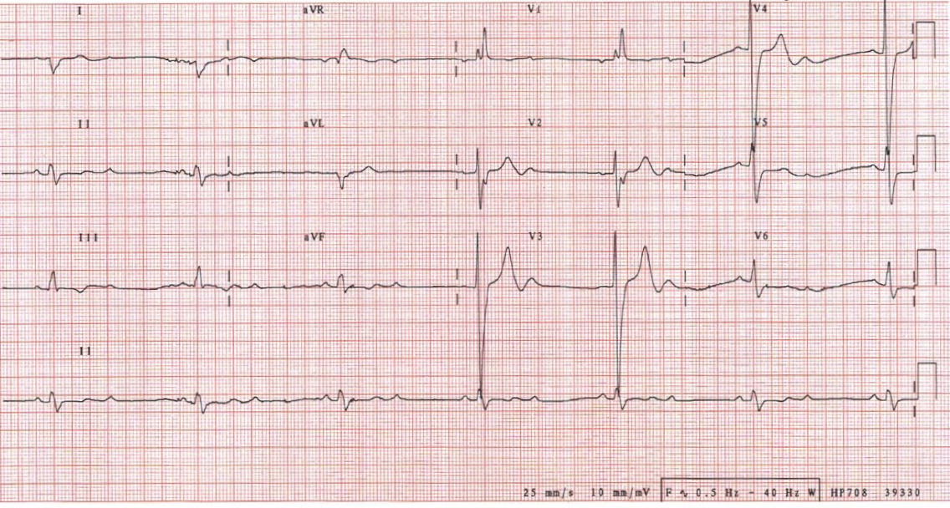  2nd Degree AVB Mobitz 2 | 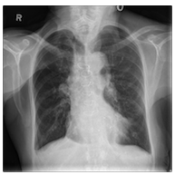
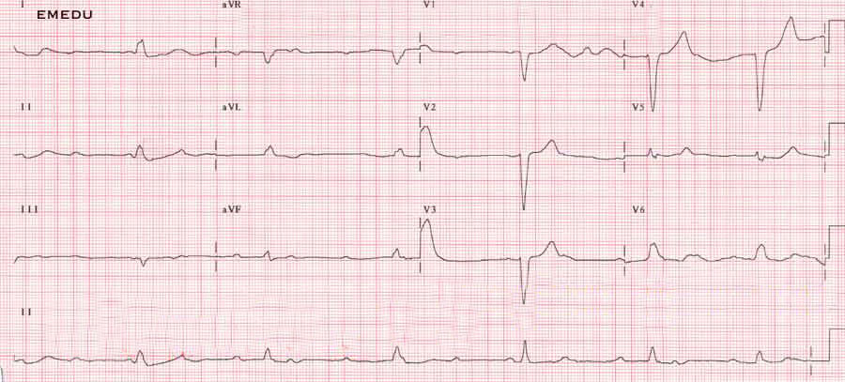
3rd Degree AVB

Ultrasound Video Files (if applicable)
U/S Showing non-capture | U/S Showing Capture
Section VIII: Debriefing Guide

General Debriefing Plan
Individual | Group |  | With Video | Without Video
Objectives
Educational Goal: |  | To manage a patient with unstable bradycardia leading to cardiac arrest
CRM Objectives: |  | - Predicts the likelihood of deterioration in a patient with bradycardia and describes a plan of management to team members.  - Recognizes the need to effectively utilize resources by optimizing pharmacologic therapy and instituting transcutaneous pacing in addition to early consultation with cardiology for placement of an intravenous pacemaker.
Medical Objectives: |  | - Employ a intravenous chronotropic agent for unstable bradycardia  - Promptly recognize pulseless electrical activity in the setting of an unstable patient.
Sample Questions for Debriefing
- How to you prepare the team for potential deterioration of the patient?
- Why does Atropine tend not to improve in high-degree AV Blocks?
- What are ways to check for electromechanical capture during pacing?
- How to you start and maintain pacing for symptomatic bradycardia?
- What is the ultimate disposition for patients with 3rd degree AVB?
Key Moments
1) Deterioration from 2nd to 3rd degree AVB
2) PEA arrest
3) Electromechanical Capture

